Git Assignment

https://github.com/tarun3834

GCP console

create a local git repository developerA and create 3 files into it.

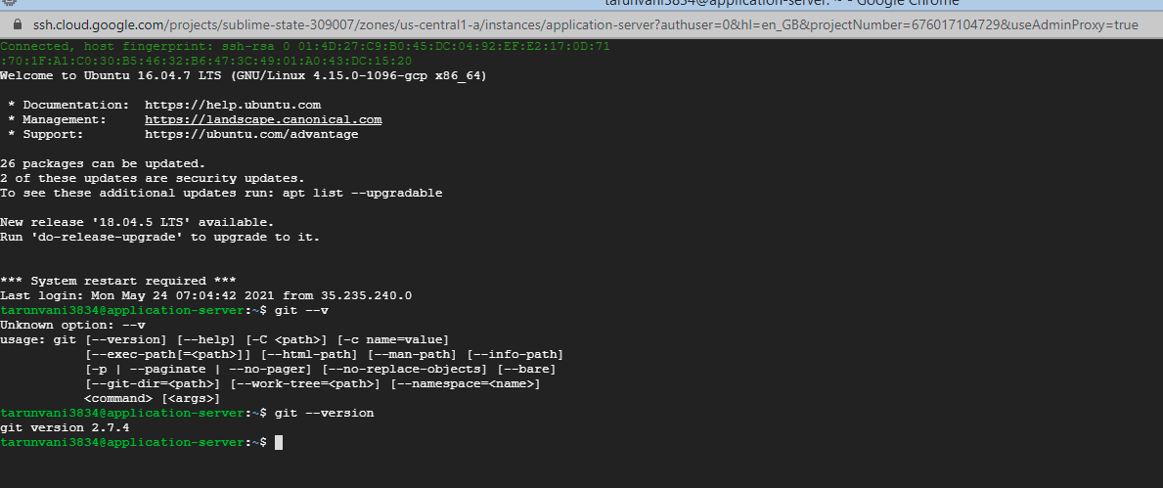

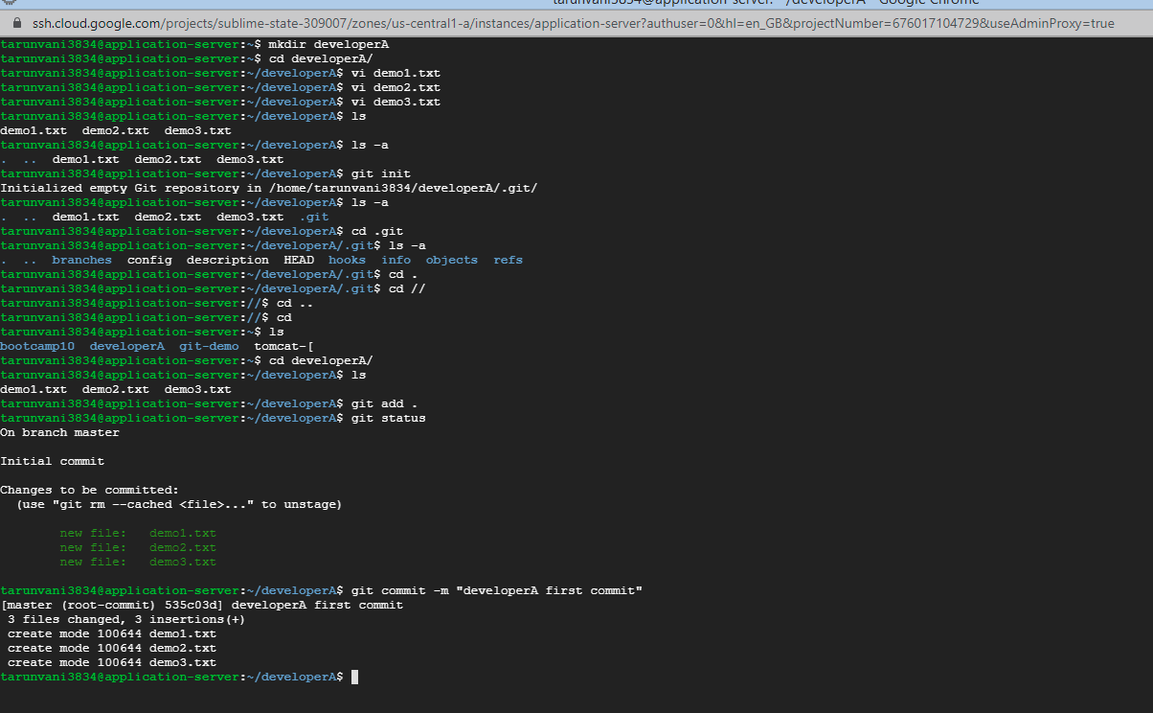

create a remote repository in github

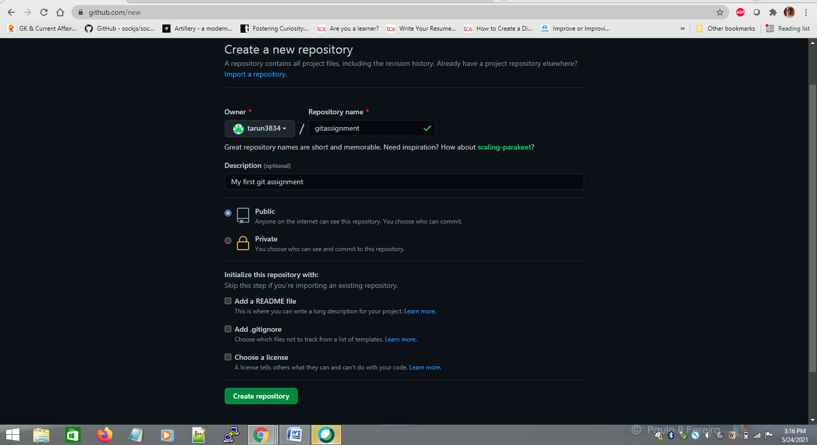

https://github.com/tarun3834/gitassignment

https://github.com/tarun3834/gitassignment.git

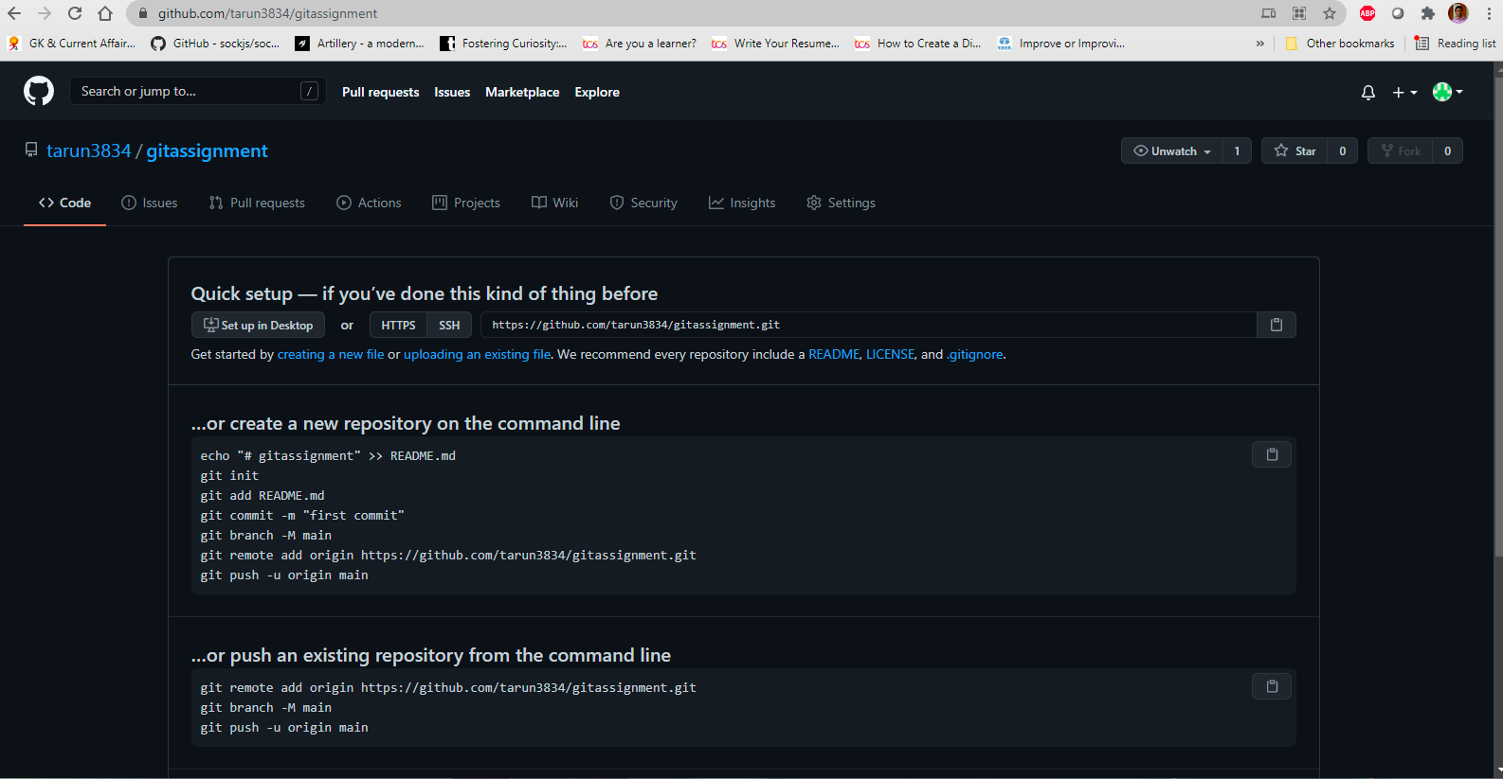

Add the remote repository to the local repository and push the changes.

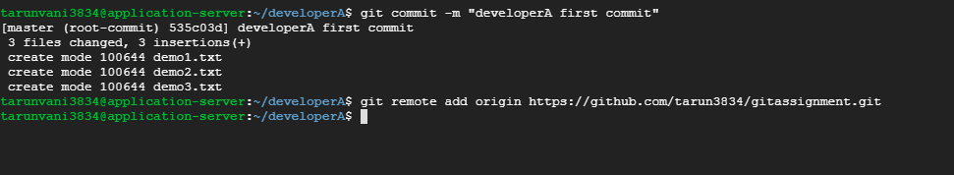

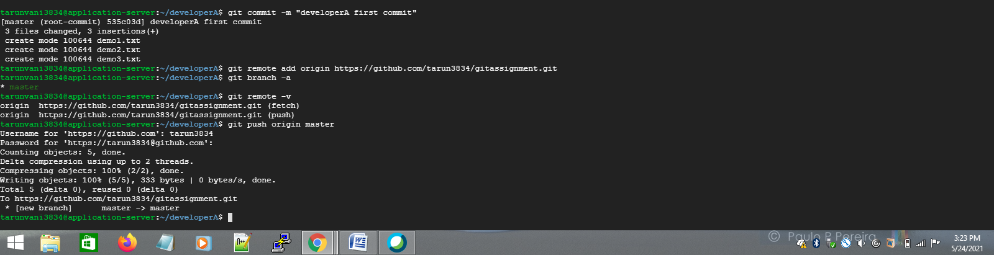

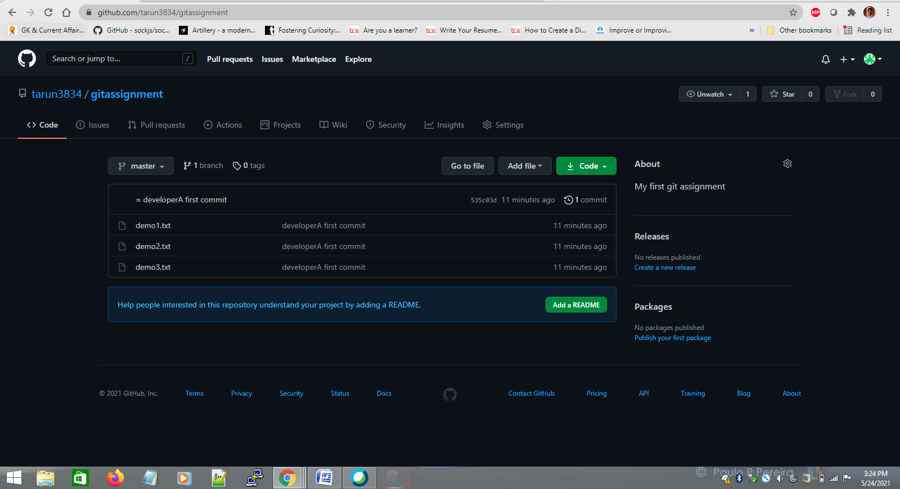

Clone the remote repo to another folder developerB

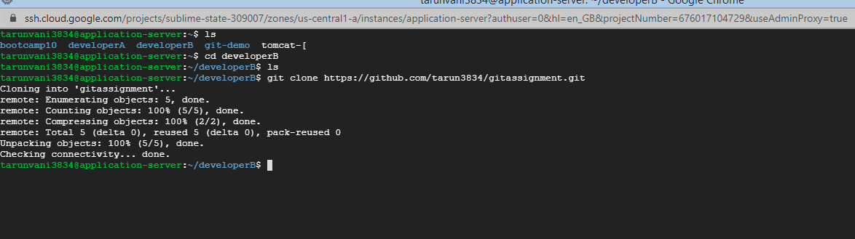

Make and commit the changes via developer B and synchronize the changes in developer A repository.

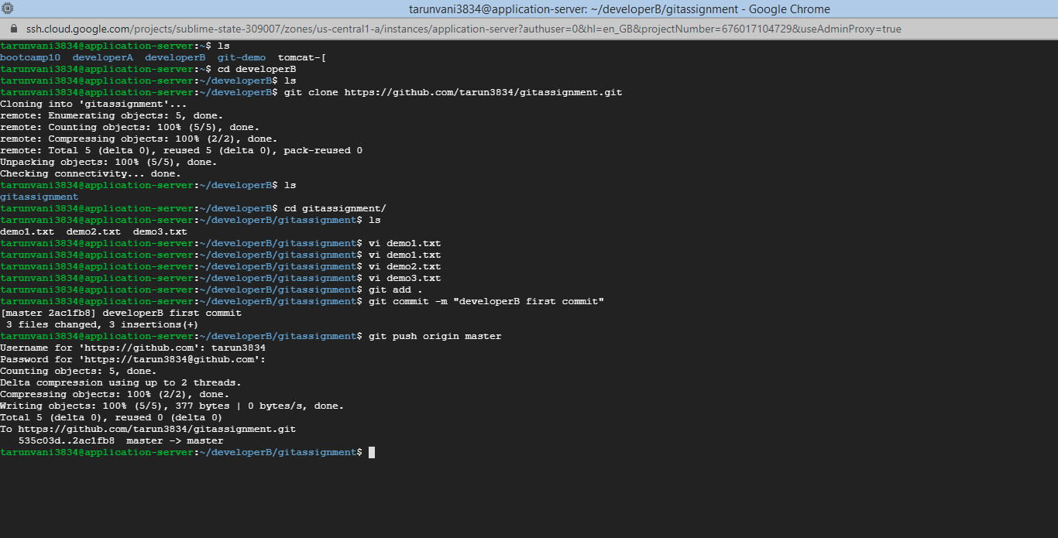

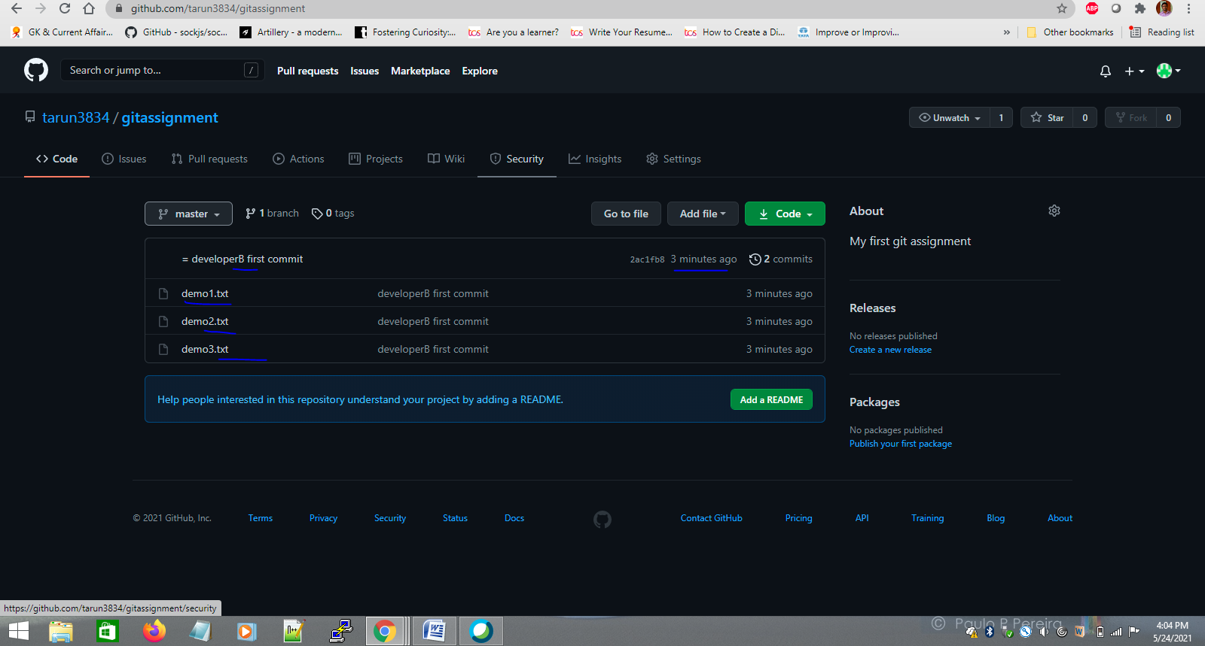

create a new branch for a new feature and change the files.

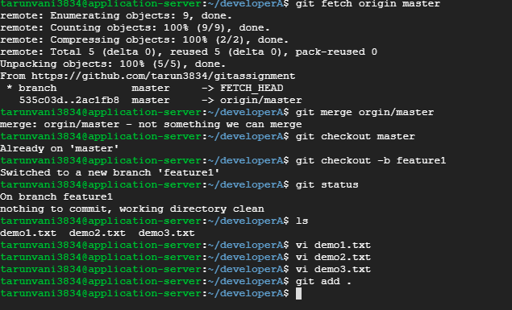

merge back the created branch with the master branch

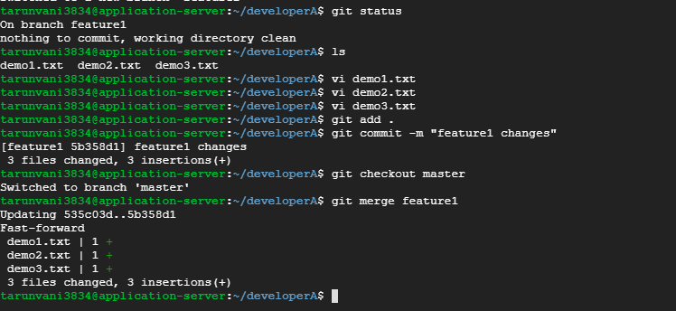

delete the feature branch after merging

